
VIRGINIA COMMONWEALTH UNIVERSITY

Statistical analysis and modelling (SCMA 632)

A4a: Principal Component Analysis and Factor Analysis
A4b: Cluster Analysis
A4c: Multi-dimensional Scaling
A4d: Conjoint Analysis

DEEPTHI ANNA ALEX
V01101949

Date of Submission: 08-07-2024

CONTENTS
Content: | Page no:
A4a | 3-11
A4b | - 15
A4c | 15-19
A4d | 19-20

A4a

Introduction:

What is PCA( Principal Component Analysis) ?
One of the most often discussed machine learning techniques online is principal component analysis (PCA). A lot of the articles about it go into too much depth, even though there are some excellent ones. Those without a strong foundation in mathematics can nonetheless comprehend and utilize principal component analysis thanks to the straightforward, step-by-step explanation of its operation provided below.
A huge data set can be reduced in size while retaining important patterns and trends by using principal component analysis (PCA), a dimensionality reduction and machine learning technique.

What is Factor Analysis?
One advanced statistical technique for breaking down a large number of variables into a smaller set of factors is factor analysis. By taking the largest common variance from each variable and combining them into a single score for additional analysis, this technique is useful. Factor analysis, as part of the general linear model (GLM), is based on a number of fundamental assumptions, including linearity, the lack of multicollinearity, the inclusion of pertinent variables, and a real connection between variables and factors.

Objective

4a) .To identify data dimensions, Principal Component interpretation (PCA) is used to minimize the complexity of the data-set while preserving its most significant variation. This makes display and interpretation of the data easier.

The objective of performing Factor Analysis to identify data dimensions is to uncover the underlying relationships between variables by reducing the dataset to a smaller set of latent factors.

Interpretation and Results

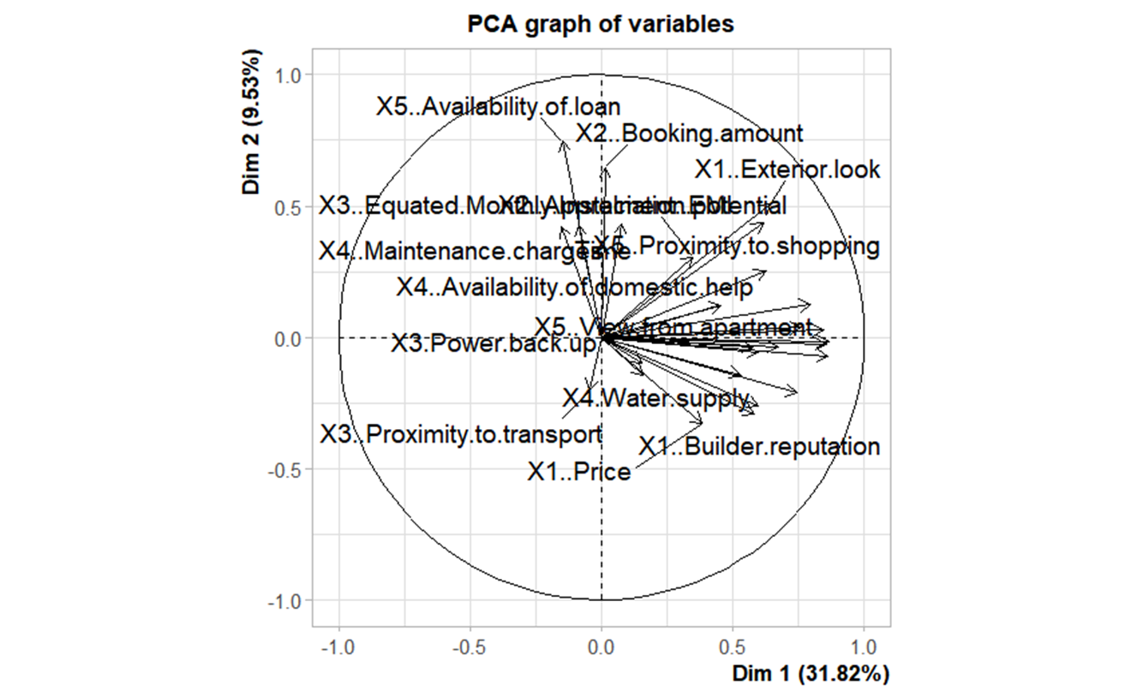

PCA biplot
You probably notice that a PCA biplot simply merge an usual PCA plot with a plot of loadings. The arrangement is like this:
- Bottom axis: PC1 score.
- Left axis: PC2 score.
- Top axis: loadings on PC1.
- Right axis: loadings on PC2.
In other words, the left and bottom axes are of the PCA plot — use them to read PCA scores of the samples (dots). The top and right axes belong to the loading plot — use them to read how strongly each characteristic (vector) influence the principal components.

The graph provided is a Principal Component Analysis (PCA) biplot of variables. Here's a detailed analysis of the PCA graph:
Key Points of the PCA Graph:
- Principal Components (PCs):

- The PCA graph plots the first two principal components, Dim 1 (Principal Component 1) and Dim 2 (Principal Component 2).
- Dim 1 accounts for 31.82% of the variance.
- Dim 2 accounts for 9.53% of the variance.
- Together, these two dimensions explain 41.35% of the total variance in the data.

- Variable representation
- Each arrow represents a variable from the dataset.
- The direction and length of the arrows indicate how each variable contributes to the principal components.
- Arrows pointing in the same direction are positively correlated.
- Arrows pointing in opposite directions are negatively correlated.
- The closer the arrow is to the circle's edge, the stronger the contribution of the variable to the principal component.

- Interpretation of Variable Clusters
- Variables such as X5..Availability.of.loan, X2..Booking.amount, X1..Exterior.look, X1..Price, and X1..Builder.reputation have significant contributions to the first principal component (Dim 1) due to their long arrows close to the circle's edge.
- Variables such as X4..Water.supply, X3..Proximity.to.transport, and X4..Availability.of.domestic.help contribute notably to the second principal component (Dim 2).
- The variables clustered near the origin have lower contributions to these two principal components.

- Variable Contributions
- Variables that are far from the origin, such as X1..Price and X1..Builder.reputation, have a high contribution to the variance explained by the first principal component.
- Variables like X4..Availability.of.domestic.help and X4..Water.supply show strong contributions to the second principal component.
- Correlation and Interpretation
- The plot helps identify groups of variables that are correlated. For example, X1..Price and X1..Builder.reputation are closely aligned, indicating they are positively correlated.
- X2..Booking.amount and X5..Availability.of.loan are also closely related, suggesting a positive correlation.
- Opposing directions, such as between X3..Proximity.to.transport and X1..Builder.reputation, suggest a negative correlation between these variables.

Conclusion:
The PCA biplot is useful for visualizing the relationships between variables and understanding their contributions to the principal components. It reveals that the first principal component is heavily influenced by variables related to the financial and physical attributes of a property (e.g., price, builder reputation), while the second principal component is more influenced by location and utility factors (e.g., proximity to transport, water supply). This helps in identifying key factors and their relationships within the datas

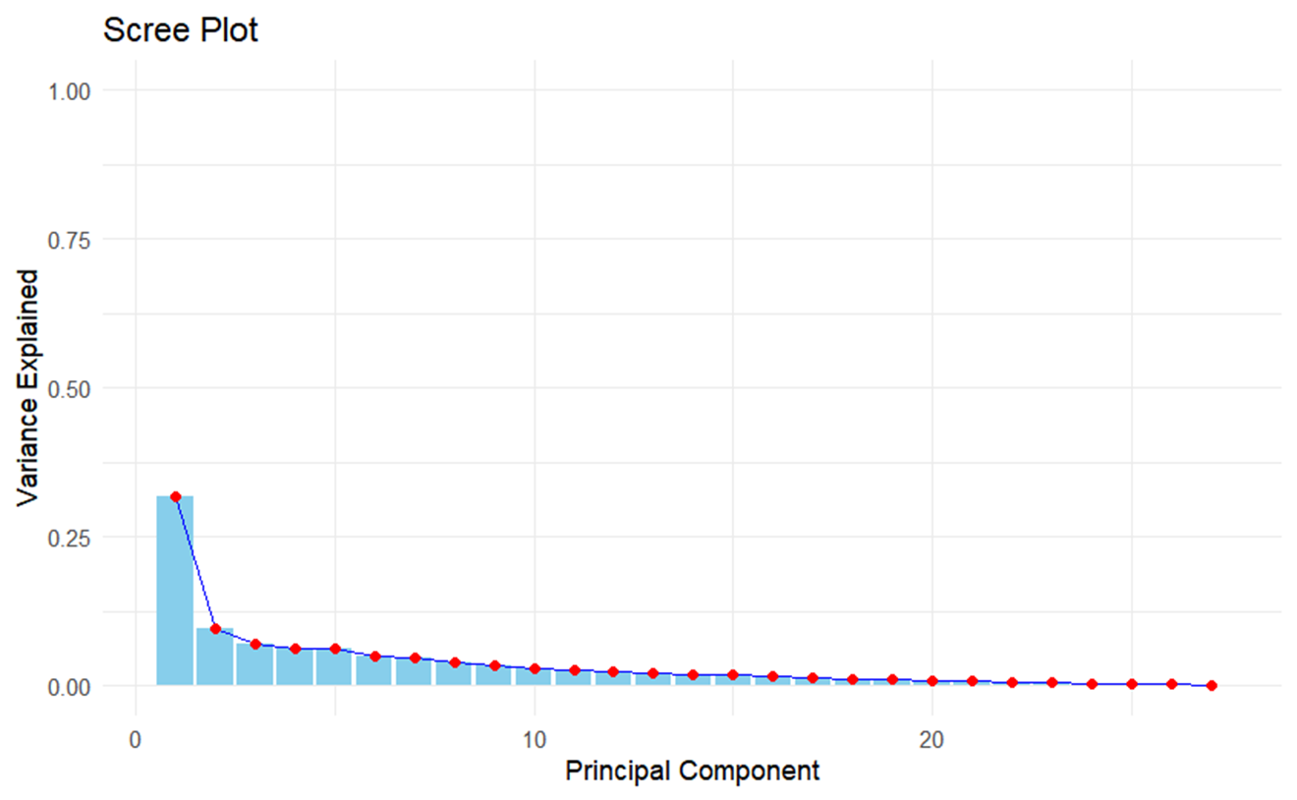

Interpretation:
- Significant Principal Components:
- The first principal component explains a significant portion of the variance, roughly around 27% (as indicated by the first bar's height).
- The second principal component explains a smaller but still notable portion of the variance, roughly around 10%.
- After the first two principal components, the variance explained by subsequent components drops sharply and levels off.
- Elbow Criterion:

- The "elbow" point in the scree plot is used to determine the optimal number of principal components to retain.
- In this scree plot, the elbow appears to occur after the second principal component, suggesting that the first two components capture most of the significant variance.
- Beyond this point, additional principal components contribute relatively little to explaining the variance, indicating diminishing returns.

- Cumulative Variance:
- The cumulative variance explained by the first few principal components can be seen rising steeply at the beginning and then plateauing.
- The plot shows that after about the second or third principal component, the cumulative variance explained increases very slowly, reinforcing the idea that only the first few components are necessary to capture the majority of the variance in the data.

Conclusion:
Based on the scree plot, it would be reasonable to retain the first two principal components for further analysis, as they capture the majority of the variance in the dataset. This conclusion aligns with the observed "elbow" point in the plot. Retaining more components beyond the first two would result in diminishing returns, as indicated by the relatively flat line in the plot after the initial components.

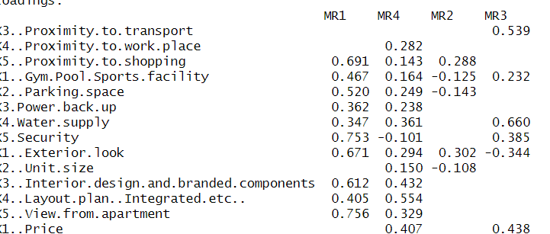

factor analysis
MR1=X5 Proximity, X1Gym ,X2 Parking,X3 Power backup, X5Security ,X1 Exterior looks
MR3= Water supply
MR4= Layout Plan, Builder Reputation
MR2= Booking amount, EMI,Loan, Time

Factor name | Latent variable name
MR1 | Amenities
MR2 | financial
MR3 | facilities
MR4 | Layout plan

Variables with Loadings Above 0.5
- Factor MR1:
  - X5..Security: 0.753
  - X1..Exterior.look: 0.671
  - X5..View.from.apartment: 0.756
  - X3..Interior.design.and.branded.components: 0.612
  - X3..Profile.of.neighbourhood: 0.590
  - X4..Availability.of.domestic.help: 0.741
- Factor MR2:
  - X5..Proximity.to.shopping: 0.691
  - X5..Availability.of.loan: 0.872
- Factor MR3:
  - X4..Water.supply: 0.660
  - X1..Price: 0.707
  - X3..Equated.Monthly.Instalment..EMI.: 0.520
- Factor MR4:
  - X4..Layout.plan..Integrated.etc..: 0.554
  - X1..Builder.reputation: 0.578
  - X2..Booking.amount: 0.516
  - X2..Appreciation.potential: 0.516
  - X3..Profile.of.neighbourhood: 0.590
  - Time: 0.701
  - Size: 0.769
  - Budgets: 0.769
  - Maintainances: 0.728
  - EMI.1: 0.775
Interpretation
- Strong Associations: Variables with loadings above 0.5 indicate strong associations with the corresponding factors. For example, in Factor MR1, variables like security features (X5..Security), exterior aesthetics (X1..Exterior.look), and view (X5..View.from.apartment) are strongly related.
- Factor Significance: Factors with multiple variables having high loadings suggest they represent meaningful dimensions in your data. For instance, Factor MR4 includes variables related to property size, budgets, maintenance costs, and various financial aspects (X1..Price, X2..Booking.amount, Size, Budgets, etc.).
- Use in Analysis: These factors can be used to summarize and understand patterns in your data. They represent underlying dimensions that explain correlations between the observed variables.
Visual Representation
You can visualize these relationships using tools like biplots or correlation matrices to better understand how variables cluster together and relate to each factor.

RC1 RC5 RC2 RC4 RC3
SS Loadings 5.69 4.47 2.42 1.88 1.91
proportion va 0.21 0.17 0.09 0.07 0.07
cumulative va 0.21 0.38 0.47 0.54 0.61
proportion ex 0.35 0.27 0.15 0.12 0.12
cummulative pro 0.35 0.62 0.77 0.88 1.00

The table you've provided seems to be related to a factor analysis or principal component analysis (PCA), specifically summarizing results such as loadings, variance explained, and cumulative variance explained for different components (RC1 to RC5). Let's break down each section of the table:
Explanation of Each Section
- SS Loadings:
  - This section typically shows the sum of squared loadings (SS Loadings) for each component (RC1 to RC5).
  - It represents the amount of variance in the original variables explained by each component.
- Proportion of Variance (va):
  - This section shows the proportion of total variance in the data explained by each component.
  - For example, RC1 explains 21% of the total variance, RC2 explains 9%, and so on.
  - These values are also referred to as eigenvalues in the context of PCA.
- Cumulative Proportion (cummulative va):
  - This section shows the cumulative proportion of variance explained by the components.
  - It helps in understanding how much of the total variance is explained as you include more components.
  - For example, RC1 explains 21%, RC1 + RC5 explain 38%, and so forth.
- Proportion of Variance Explained (proportion ex):
  - This section shows the proportion of the original variance in the data that is explained by each component.
  - It is often used to determine how well a component represents the original variables.
- Cumulative Proportion of Variance Explained (cummulative pr):
  - This section shows the cumulative proportion of variance explained by the components.
  - It helps in assessing how much of the original variance in the data is explained as more components are included.
Example Interpretation
Let's interpret a hypothetical example based on the data you've provided:
- RC1 (Component 1):
  - SS Loadings: 5.69
  - Proportion of Variance: 21%
  - Cumulative Proportion: 21%
  - Proportion of Variance Explained: 35%
  - Cumulative Proportion of Variance Explained: 35%
This component (RC1) has the highest sum of squared loadings (5.69), explaining 21% of the total variance in the data. When included alone, it explains 35% of the original variance.
- RC5 (Component 5):
  - SS Loadings: 1.91
  - Proportion of Variance: 7%
  - Cumulative Proportion: 61%
  - Proportion of Variance Explained: 12%
  - Cumulative Proportion of Variance Explained: 100%
This component has the smallest sum of squared loadings among those listed (1.91), explaining 7% of the total variance. When combined with previous components (RC1 to RC4), it contributes to a cumulative proportion of variance explained reaching 100%.
Conclusion
The table summarizes key metrics from a factor analysis or PCA, providing insights into how each component contributes to explaining the variance in the original dataset. It's useful for understanding the relative importance of each component and deciding how many components to retain based on the cumulative proportion of variance explained.

A4b

Introduction:
What is Cluster Analysis?
Cluster analysis is a statistical technique used to classify objects or data points into distinct groups, or clusters, based on their similarities. The primary objective is to ensure that data points within a cluster are more similar to each other than to those in different clusters, utilizing various distance metrics to measure similarity. This technique is widely applied in fields such as marketing for customer segmentation, biology for classifying species, and image processing for segmenting images. Different methods of clustering include partitioning methods like K-Means, hierarchical methods, density-based methods like DBSCAN, and model-based methods like Gaussian Mixture Models. Determining the optimal number of clusters is crucial and can be achieved through methods like the Elbow Method, Silhouette Score, or Gap Statistic, making cluster analysis a versatile and powerful tool for pattern recognition and data simplification.

Objective
The objective of conducting Cluster Analysis to characterize respondents based on background variables is to identify homogeneous groups or segments within the dataset, grouping respondents who share similar characteristics together. This helps in understanding patterns, segmenting the data for targeted analysis or interventions, and gaining insights into different respondent profiles.

Interpretation and Results

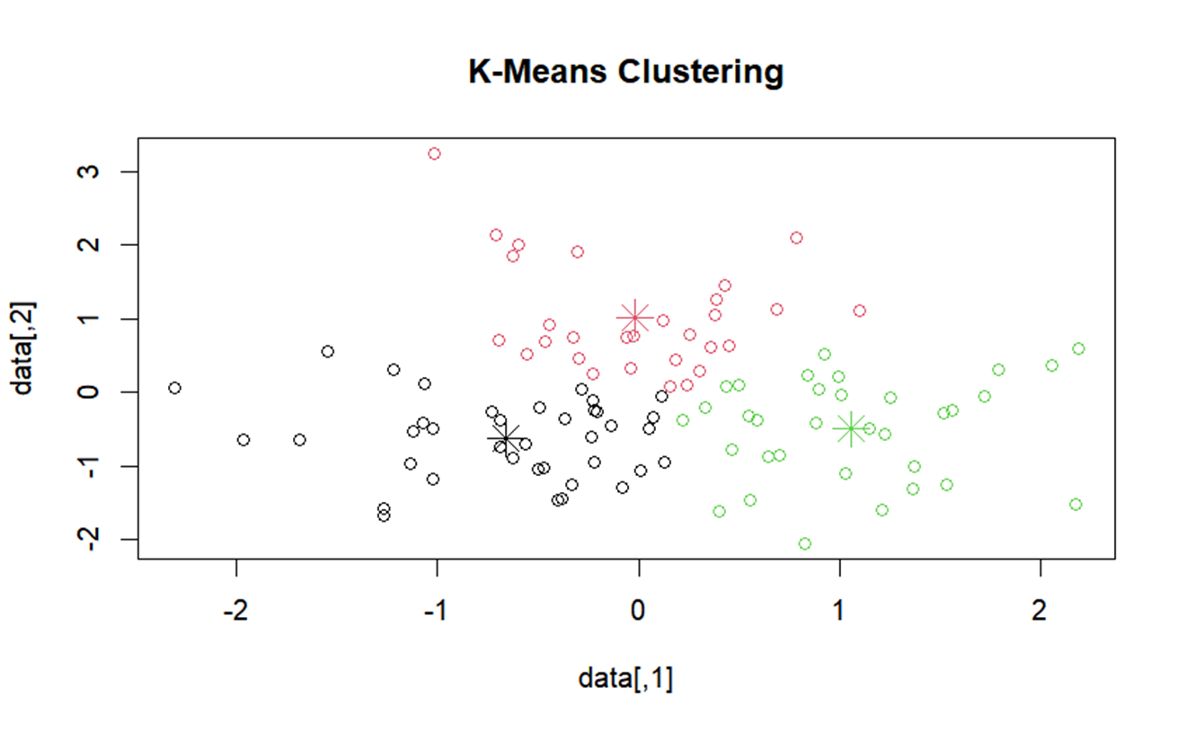
- Cluster Separation:
- The three clusters are relatively well-separated, indicating that the K-means algorithm has effectively grouped the data points based on their similarities.
- The black cluster appears on the left side of the plot, the red cluster is towards the center, and the green cluster is on the right side.
- Centroid Positions:
- The centroids are located at the center of each cluster, indicating the central tendency of the data points in each cluster.
- The centroid positions are approximately (-1.2, 0.1) for the black cluster, (0.1, 1.2) for the red cluster, and (1.2, -0.5) for the green cluster.
3)Cluster Characteristics:
- Data points within the same cluster are more similar to each other than to those in other clusters.
- The distance of points from their respective centroids gives an indication of the compactness of the clusters. Clusters with points close to their centroids are more compact and homogeneous.
4)Cluster Overlap:
- There is some overlap between the clusters, particularly between the black and red clusters. This overlap might indicate some similarity or ambiguity in the data points that lie near the boundary between these clusters.
Conclusion:
The K-means clustering plot shows a clear separation of the data into three distinct clusters, each represented by different colors. The centroids of these clusters are indicated by large asterisks, marking the central points around which the data points are grouped. This visualization helps in understanding the distribution and grouping of the data points based on the K-means clustering algorithm. The plot provides insight into the structure of the data, highlighting similarities within clusters and differences between clusters.

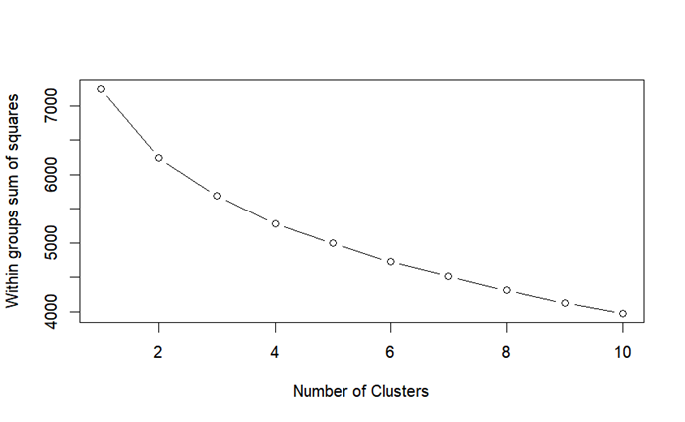

- The graph you've provided is an Elbow Plot, which is used to determine the optimal number of clusters in a clustering algorithm, such as K-means clustering. Here is a step-by-step interpretation:
- X-axis (Number of Clusters): This axis shows the number of clusters, ranging from 1 to 10 in this plot.
- Y-axis (Within groups sum of squares): This axis represents the within-cluster sum of squares (WCSS), which measures the total variance within each cluster. Lower values of WCSS indicate that the clusters are more compact.
- Plot Description: The plot displays a curve that shows how the WCSS decreases as the number of clusters increases. Initially, the WCSS decreases sharply with the addition of the first few clusters, indicating that these clusters are effectively capturing the variance in the data.
- Elbow Point: The "elbow" point of the plot is the point where the rate of decrease sharply slows down, indicating diminishing returns in reducing WCSS with the addition of more clusters. This is considered the optimal number of clusters because it balances compactness with simplicity. In this plot, the elbow appears to be around 3 or 4 clusters.

To summarize, the Elbow Plot suggests that the optimal number of clusters for this dataset is likely around 3 or 4. This is the point where adding additional clusters beyond this number does not significantly reduce the WCSS.

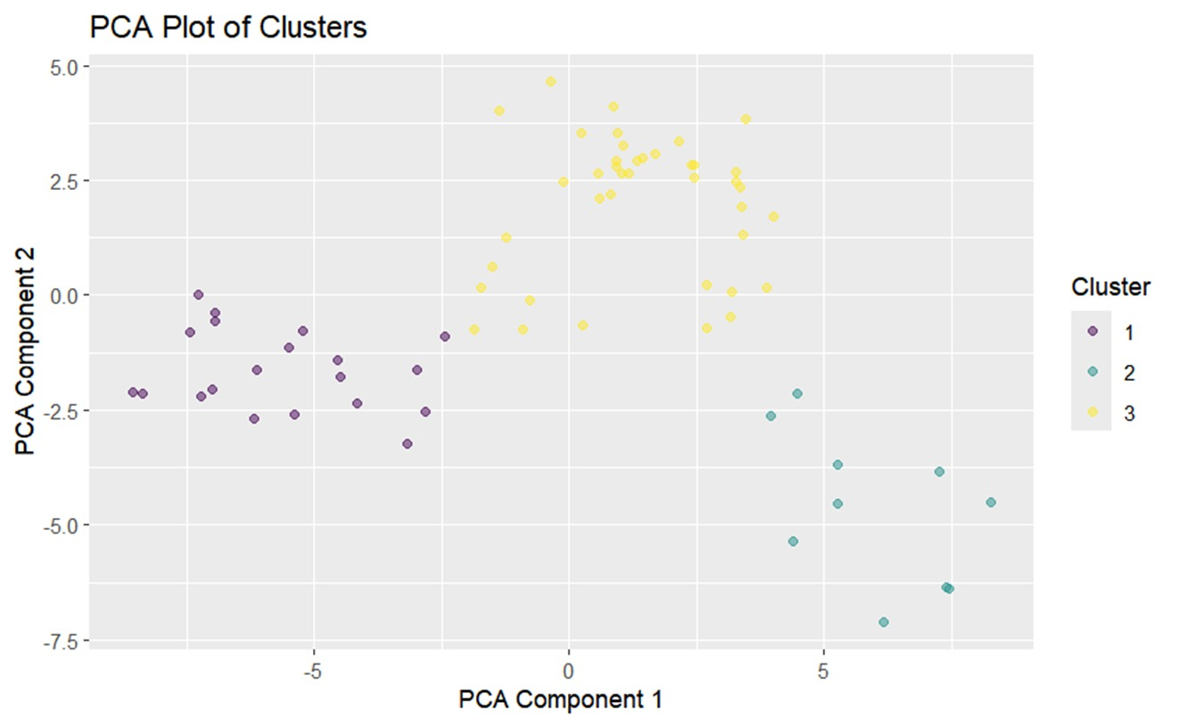

• Cluster Separation: The plot shows three distinct clusters, each represented by a different color. The separation between clusters indicates that the clustering algorithm has successfully grouped similar data points together.
• • Cluster 1 (Purple): These points are mostly concentrated in the bottom left quadrant of the plot. This indicates that data points in Cluster 1 have similar characteristics as captured by the first two principal components.
• • Cluster 2 (Cyan): These points are spread out towards the right side of the plot. Cluster 2 is distinct from Cluster 1 and Cluster 3, indicating a different group of similar data points.
• • Cluster 3 (Yellow): These points are mainly located in the upper and middle parts of the plot, with a clear separation from the other two clusters.
• • Cluster Characteristics: The distance between clusters suggests that the clusters are well-separated, with minimal overlap. This indicates that the clustering algorithm has effectively identified distinct groups within the data.

A4c

Introduction:
What is Multidimensional Scaling?
Multidimensional scaling (MDS) is a statistical technique used to analyze similarity or dissimilarity data between a set of objects. It aims to represent these relationships in a lower-dimensional space, typically two-dimensional, while preserving the original pairwise distances as much as possible. MDS is useful for visualizing and interpreting complex patterns of similarity or dissimilarity among objects when direct measurement in a lower-dimensional space is desired for easier understanding and analysis.

Objective
The objective of applying Multidimensional Scaling (MDS) is to visualize and interpret relationships among objects by transforming similarity or dissimilarity data into a lower-dimensional space while preserving pairwise distances.

Interpretation and Results
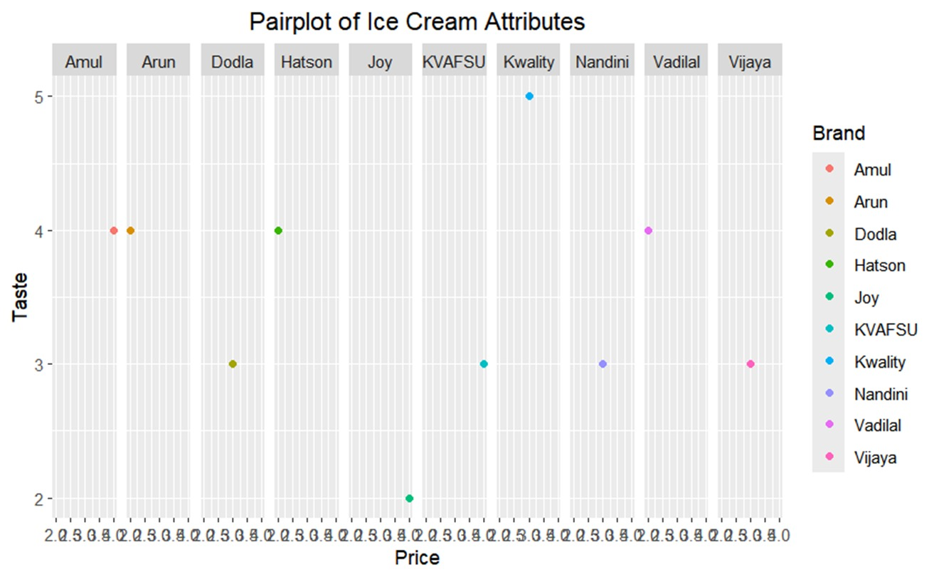

1)Brand Distribution:

- Amul (Red): Amul has a price of around 4.5 and a taste rating close to 4.
- Arun (Orange): Arun is priced around 2.0 with a taste rating slightly above 4.
- Dodla (Brown): Dodla is priced around 3.0 with a taste rating slightly above 3.
- Hatson (Green): Hatson is priced around 3.0 with a taste rating close to 4.
- Joy (Light Blue): Joy has a price close to 4.0 and a taste rating of around 3.
- KVAFSU (Blue): KVAFSU is priced around 2.5 with a taste rating close to 3.
- Kwality (Purple): Kwality is priced around 3.5 with a taste rating of 3.
- Nandini (Violet): Nandini is priced around 4.0 with a taste rating of around 3.
- Vadilal (Pink): Vadilal is priced around 3.5 with a taste rating slightly above 4.
- Vijaya (Dark Pink): Vijaya is priced around 3.0 with a taste rating close to 3.

2)Price and Taste Trends:
- Higher Taste Ratings: Brands like Amul, Arun, and Hatson have higher taste ratings, around 4.
- Moderate Taste Ratings: Most brands have moderate taste ratings between 3 and 4.
- Lower Taste Ratings: Brands like Joy, KVAFSU, and Vijaya have taste ratings around 3.
- Comparative Insights:

- High Taste, Low Price: Arun offers a high taste rating at a lower price.
- High Taste, Higher Price: Amul offers a high taste rating but at a higher price.
- Moderate Taste, Moderate Price: Most brands fall into this category, offering a balance between price and taste.

Conclusion:
The pairplot effectively visualizes the relationship between price and taste for various ice cream brands. It highlights the diversity in market offerings and can help consumers and businesses make informed decisions based on these attributes.

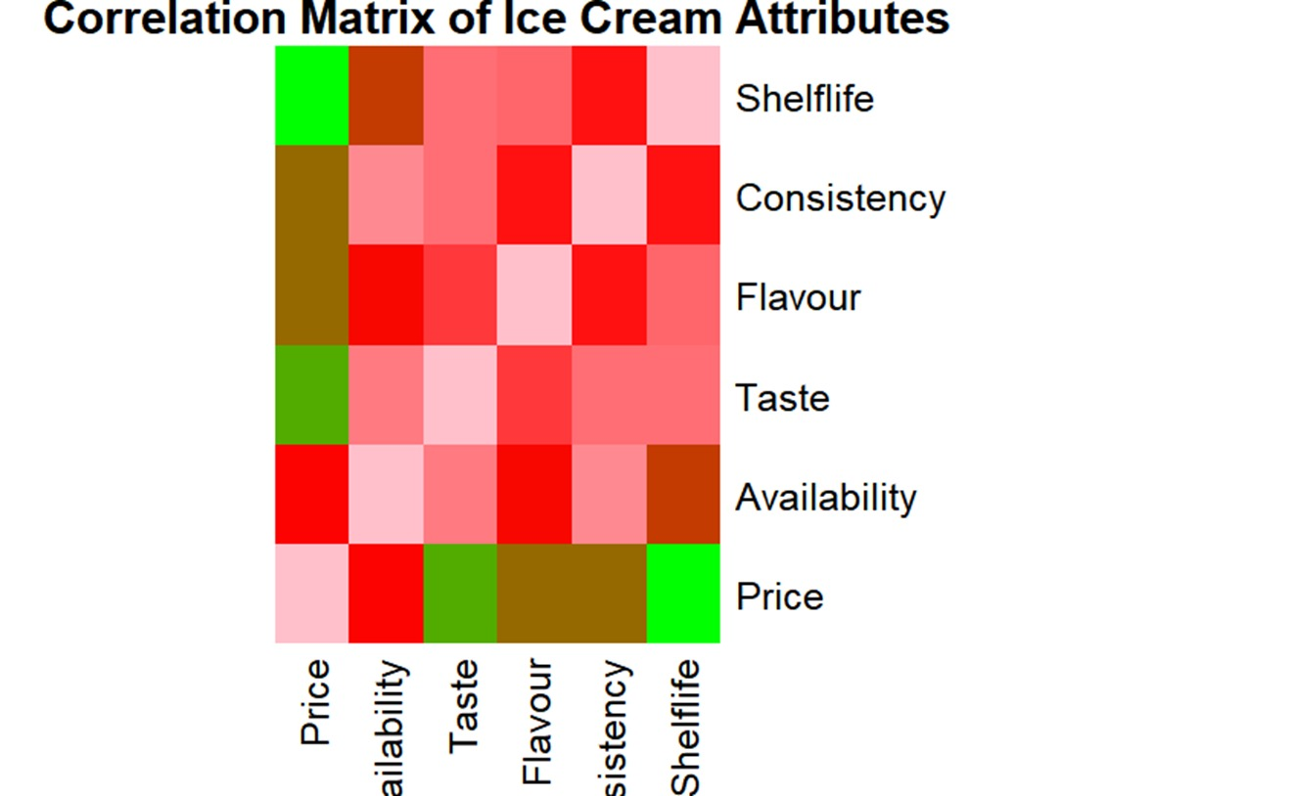

- Color Coding:
- Red shades indicate positive correlations, with darker reds showing stronger correlations.
- Green shades indicate negative correlations, with darker greens showing stronger negative correlations.
- Brown indicates near-zero or very weak correlations.
- Diagonal Line: Each attribute is perfectly correlated with itself, hence the darkest red along the diagonal.

- Notable Correlations:
- Price and Shelflife: Strong negative correlation (green), suggesting that higher prices are associated with shorter shelflife.
- Price and Flavour: Moderate positive correlation (light red), indicating that higher prices may be associated with better flavour.
- Price and Consistency: Moderate positive correlation (light red), indicating that higher prices may be associated with better consistency.
- Availability and Price: Moderate negative correlation (green), suggesting that higher availability may be associated with lower prices.
- Taste and Flavour: Strong positive correlation (dark red), indicating that better flavour is associated with better taste.
- Flavour and Consistency: Moderate positive correlation (light red), indicating that better flavour is associated with better consistency.
4)Other Observations:
- Availability and Shelflife: Near-zero correlation (brown), suggesting no strong relationship between availability and shelflife.
- Taste and Consistency: Moderate positive correlation (light red), indicating that better taste is associated with better consistency.

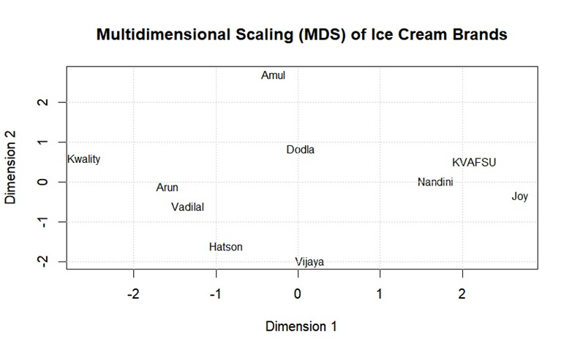
- Amul's isolated position suggests it has unique attributes that distinguish it from other brands.
- Kwality, Arun, and Vadilal being clustered together indicates that they might be competing closely in the same market segment.
- The positioning of Dodla, Nandini, KVAFSU, and Joy suggests these brands share similar characteristics and might be targeting a similar customer base.
- This MDS plot provides insights into the competitive landscape and positioning of different ice cream brands, which can be useful for market analysis and strategic planning.

A4d

Introduction:

What is Conjoint Analysis?

Conjoint analysis is a market research technique used to determine how consumers value different features of a product or service. By presenting respondents with various combinations of product attributes and analyzing their preferences, conjoint analysis helps identify which attributes are most influential in the decision-making process. This method provides insights into consumer priorities and can guide product development, pricing strategies, and marketing efforts.

Objective
The objective of conjoint analysis is to determine the relative importance of different product attributes and how they influence consumer preferences and decision-making.

Interpretation and Results

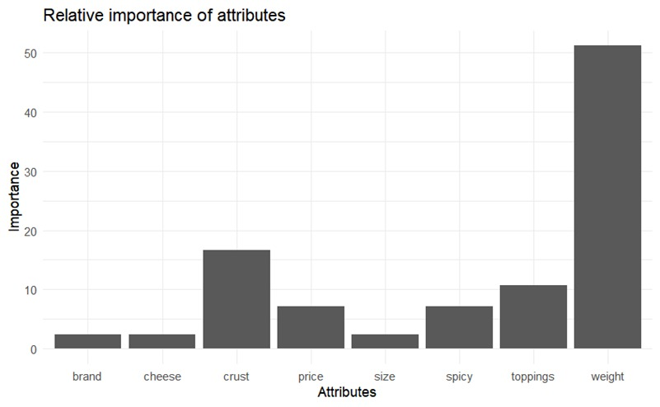

- Weight being the most important attribute indicates that it significantly influences the decision-making process or overall evaluation compared to other attributes.
- Crust and Price are also important, though to a lesser extent than Weight, suggesting that these factors are key considerations but not as critical as Weight.
- Toppings and Spicy have moderate importance, which means they are somewhat influential but not primary factors.
- Brand, Cheese, and Size are the least important attributes, suggesting they have minimal impact on the overall evaluation or decision-making process.
- This chart provides insights into which attributes are prioritized or considered most important, which can be useful for product development, marketing strategies, and understanding consumer preferences.

